Messiah Lutheran Church—

Missouri Synod



The Ascension of our Lord

Divine Service II

May 29, A+D 2014

***Acts 1:11***  *"Men of Galilee, why do you stand looking into heaven? This Jesus, who was taken up from you into heaven, will come in the same way as you saw him go into heaven." Christ has died. Christ is risen. Christ is ascended – and Christ will come again. We live our lives in this world in the sure confidence of the world to come. We live as people who know our Lord Jesus – and who know that He is coming back. This makes all the difference in how we approach the things of this world.*

**Messiah Lutheran Church**

Rev. James A. Roemke, Pastor

2026 22nd Ave. Kenosha, WI 53140

Church Office: 262-551-8182 Parsonage: 262-551-0944

Website: [www.messiahkenosha.org](http://www.messiahkenosha.org)

Email: secretary@messiahkenosha.org

Pastor’s Cell: 262-455-0255

Christ Lutheran Academy: 262-697-6044

**VISITORS WELCOME!** A special welcome to any visitors and guests who are with us today. Please introduce yourself to the pastor after the service, and we pray that the hearing and receiving of the Word of God in our midst will be filled with joy and thanksgiving!

**ATTENDANCE REGISTER:** During the offering we ask that you sign the attendance register located at the center aisle of each pew. **Please hand the filled in sheet to the usher as you exit at the end of the service. Let the usher know if you don’t have a pad in your pew.**

**A word about the Communion practice of the Lutheran Church—Missouri Synod:**

**HOLY COMMUNION** is celebrated every Sunday and on Feast Days. Visiting communicant members of the Lutheran Church—Missouri Synod are invited to commune today. All other visitors are asked to speak with the pastor before coming to the altar. If there is time before the service, introduce yourself to the pastor or an elder. Other visitors are invited to use this time for prayer. If you desire information about attending communion, you are encouraged to visit with the pastor after the service today.

**PRAYERS OF PREPARATION** may be found in the opening cover of the hymnals in each pew. Take some time before the service begins in quiet preparation and prayer.

**+SERVING TODAY+**

**Preacher/Celebrant:** Pr. Roemke

**Organist:** Lauri Trapp

**Altar Guild:** Diana Dissen & Marilyn Dissen

***A Hymn of Glory Let Us Sing*** *LSB 493*

*Stand*

*The sign of the cross may be made by all in remembrance of their Baptism.*

**INVOCATION** *p167*

**+CONFESSION AND ABSOLUTION+**

*Silence for reflection on God's Word and for self-examination.*

**+SERVICE OF THE WORD+**

**Introit** *Ps. 47:1–2, 5, 8; antiphon: Acts 1:11*



Men of | Galilee,*

why do you stand looking into heaven? Alle- | luia.

This Jesus, who was taken up from you into | heaven,*

will come in the same way as you saw him go into heaven. Alle- | luia.

Clap your hands, all | peoples!*

**Shout to God with loud | songs of joy!**

**For the Lord, the Most High, is | to be feared,\***

**a great king over | all the earth.**

**God has gone up | with a shout,\***

**the Lord with the sound of a | trumpet.**

**God reigns over the | nations;\***

**God sits on his | holy throne.**

**Glory be to the Father and** | **to the Son**\*

**and to the Holy** | **Spirit;**

**as it was in the be-** | **ginning,**\*

**is now, and will be forever.** | **Amen.**

Men of | Galilee,*

why do you stand looking into heaven? Alle- | luia.

This Jesus, who was taken up from you into | heaven,*

will come in the same way as you saw him go into heaven. Alle- | luia.

**Kyrie** *p168*

**This is the Feast** *p171*

**Salutation and Collect of the Day**

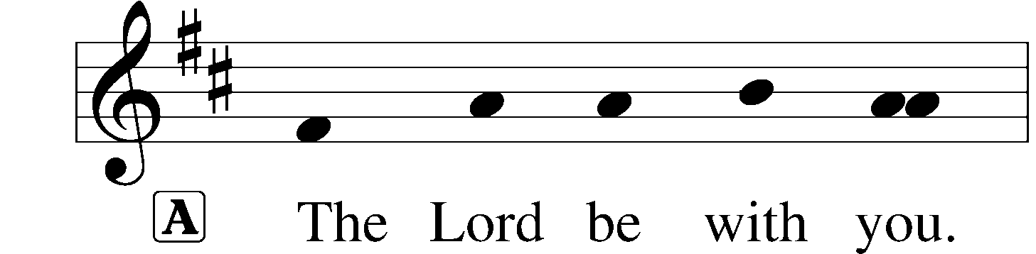

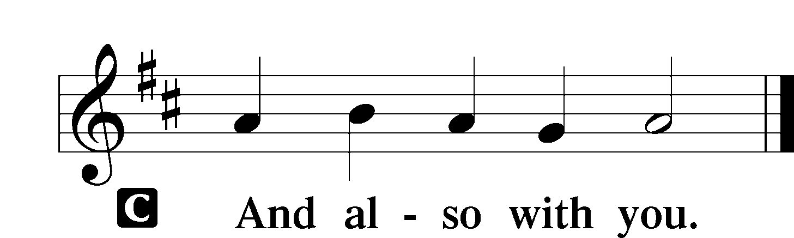

|  |  |
| --- | --- |
| P | Let us pray.    Almighty God, as Your only-begotten Son, our Lord Jesus Christ, ascended into the heavens, so may we also ascend in heart and mind and continually dwell there with Him, who lives and reigns with You and the Holy Spirit, one God, now and forever. |

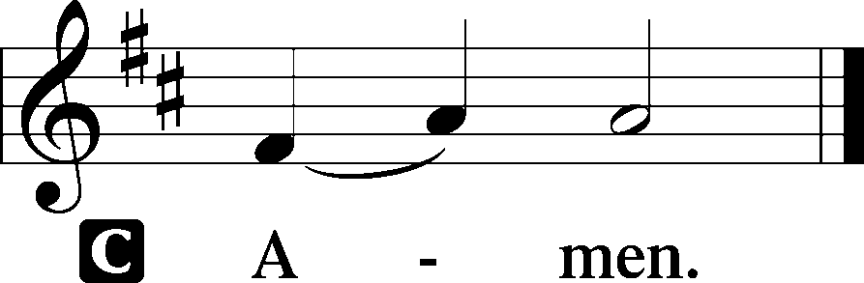

*Sit*

**Old Testament Reading** *2 Kings 2:5–15*

5The sons of the prophets who were at Jericho drew near to Elisha and said to him, “Do you know that today the Lord will take away your master from over you?” And he answered, “Yes, I know it; keep quiet.”

6Then Elijah said to him, “Please stay here, for the Lord has sent me to the Jordan.” But he said, “As the Lord lives, and as you yourself live, I will not leave you.” So the two of them went on. 7Fifty men of the sons of the prophets also went and stood at some distance from them, as they both were standing by the Jordan. 8Then Elijah took his cloak and rolled it up and struck the water, and the water was parted to the one side and to the other, till the two of them could go over on dry ground.

9When they had crossed, Elijah said to Elisha, “Ask what I shall do for you, before I am taken from you.” And Elisha said, “Please let there be a double portion of your spirit on me.” 10And he said, “You have asked a hard thing; yet, if you see me as I am being taken from you, it shall be so for you, but if you do not see me, it shall not be so.” 11And as they still went on and talked, behold, chariots of fire and horses of fire separated the two of them. And Elijah went up by a whirlwind into heaven. 12And Elisha saw it and he cried, “My father, my father! The chariots of Israel and its horsemen!” And he saw him no more.

Then he took hold of his own clothes and tore them in two pieces. 13And he took up the cloak of Elijah that had fallen from him and went back and stood on the bank of the Jordan. 14Then he took the cloak of Elijah that had fallen from him and struck the water, saying, “Where is the Lord, the God of Elijah?” And when he had struck the water, the water was parted to the one side and to the other, and Elisha went over.

15Now when the sons of the prophets who were at Jericho saw him opposite them, they said, “The spirit of Elijah rests on Elisha.” And they came to meet him and bowed to the ground before him.

|  |  |
| --- | --- |
| A | This is the Word of the Lord. |
| C | **Thanks be to God.** |

**Second Reading** *Acts 1:1–11*

1In the first book, O Theophilus, I have dealt with all that Jesus began to do and teach, 2until the day when he was taken up, after he had given commands through the Holy Spirit to the apostles whom he had chosen. 3To them he presented himself alive after his suffering by many proofs, appearing to them during forty days and speaking about the kingdom of God.

4And while staying with them he ordered them not to depart from Jerusalem, but to wait for the promise of the Father, which, he said, “you heard from me; 5for John baptized with water, but you will be baptized with the Holy Spirit not many days from now.”

6So when they had come together, they asked him, “Lord, will you at this time restore the kingdom to Israel?” 7He said to them, “It is not for you to know times or seasons that the Father has fixed by his own authority. 8But you will receive power when the Holy Spirit has come upon you, and you will be my witnesses in Jerusalem and in all Judea and Samaria, and to the end of the earth.” 9And when he had said these things, as they were looking on, he was lifted up, and a cloud took him out of their sight. 10And while they were gazing into heaven as he went, behold, two men stood by them in white robes, 11and said, “Men of Galilee, why do you stand looking into heaven? This Jesus, who was taken up from you into heaven, will come in the same way as you saw him go into heaven.”

|  |  |
| --- | --- |
| A | This is the Word of the Lord. |
| C | **Thanks be to God.** |

**Alleluia and Verse**



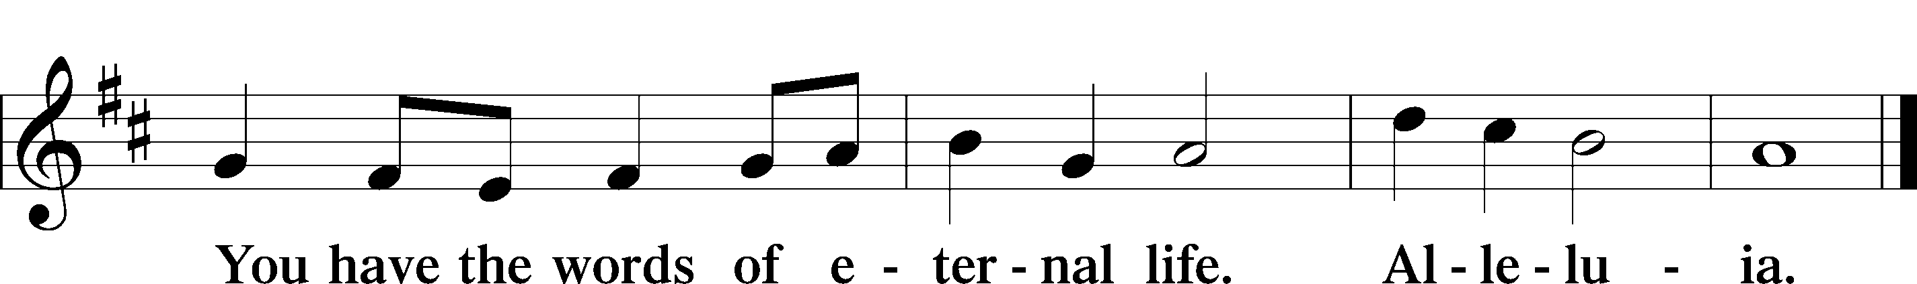

**Holy Gospel** *Mark 16:14–20*

|  |  |
| --- | --- |
| P | The Holy Gospel according to St. Mark, the sixteenth chapter. |

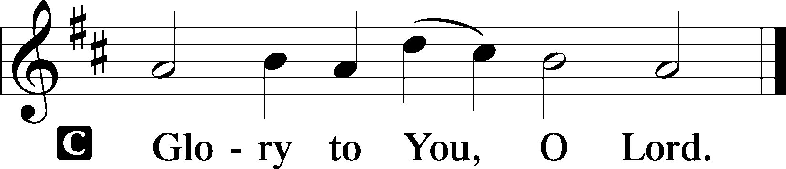

14Afterward [Jesus] appeared to the eleven themselves as they were reclining at table, and he rebuked them for their unbelief and hardness of heart, because they had not believed those who saw him after he had risen. 15And he said to them, “Go into all the world and proclaim the gospel to the whole creation. 16Whoever believes and is baptized will be saved, but whoever does not believe will be condemned. 17And these signs will accompany those who believe: in my name they will cast out demons; they will speak in new tongues; 18they will pick up serpents with their hands; and if they drink any deadly poison, it will not hurt them; they will lay their hands on the sick, and they will recover.”

19So then the Lord Jesus, after he had spoken to them, was taken up into heaven and sat down at the right hand of God. 20And they went out and preached everywhere, while the Lord worked with them and confirmed the message by accompanying signs.

|  |  |
| --- | --- |
| P | This is the Gospel of the Lord. |

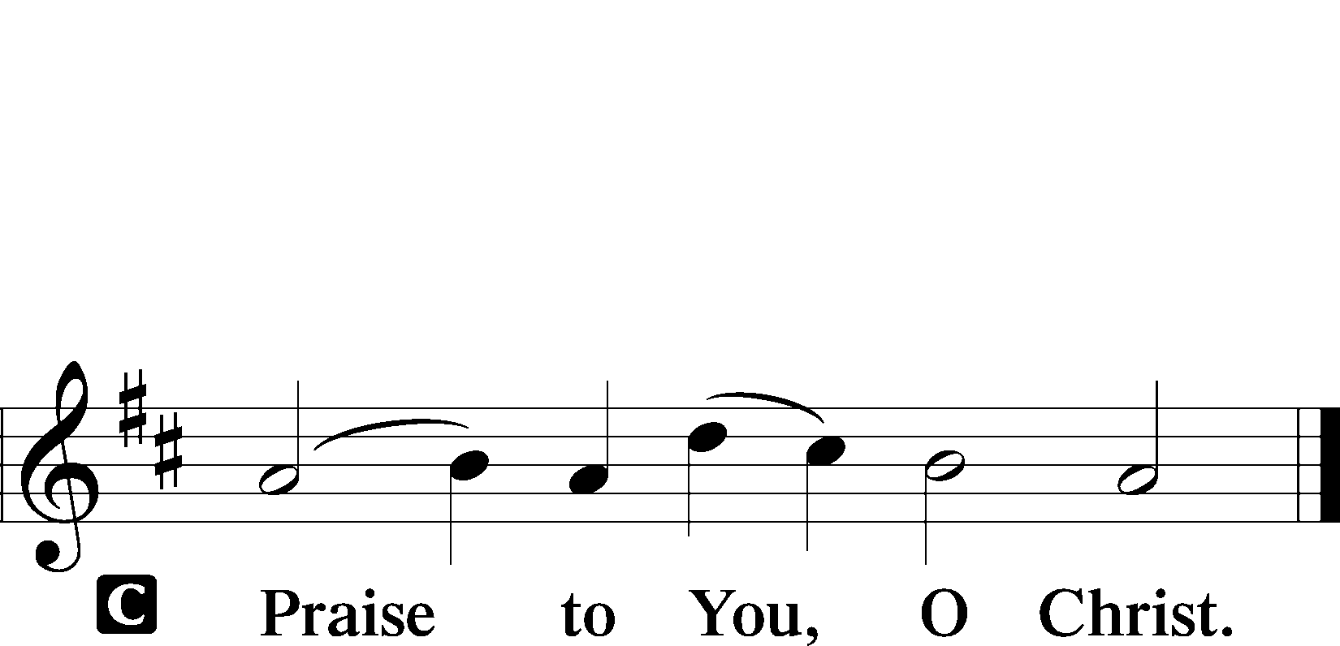

*Sit*

***Up through Endless Ranks of Angels*** *LSB 491*

**Sermon**

*Stand*

**Nicene Creed**

**Prayer of the Church**

*Sit*

**Offering**

**Offertory-New Testament Canticle**

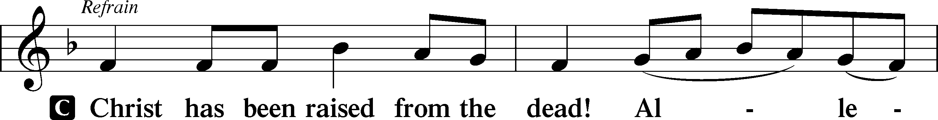



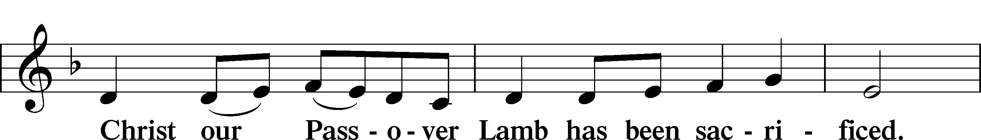

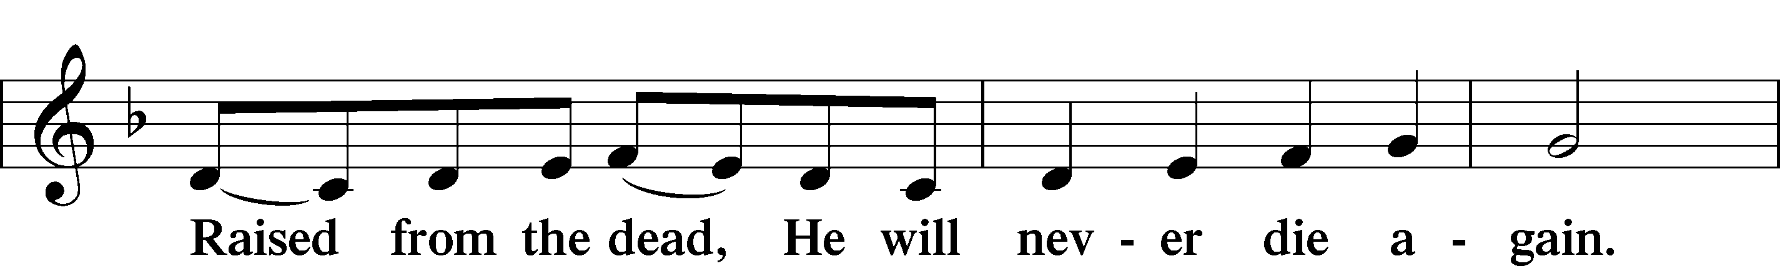

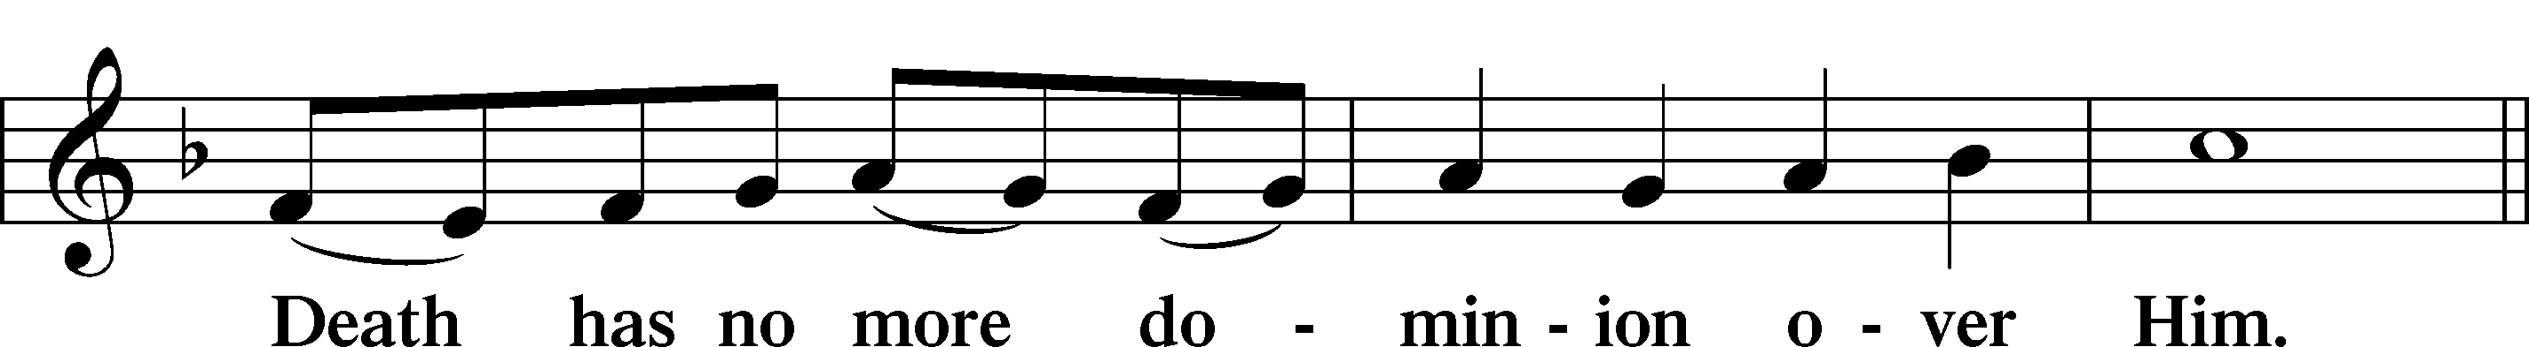

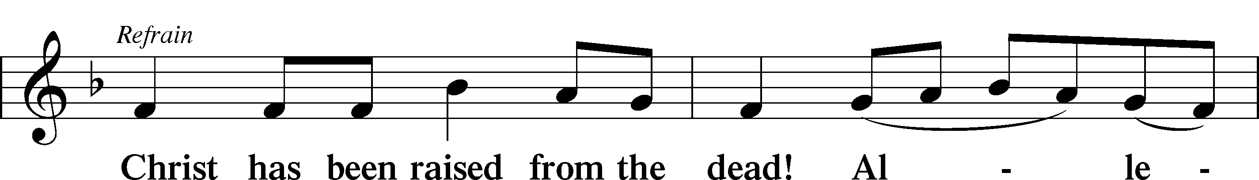



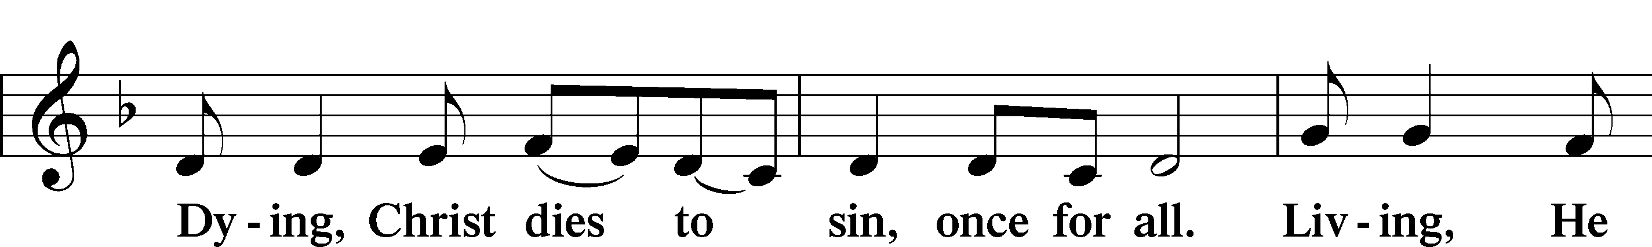



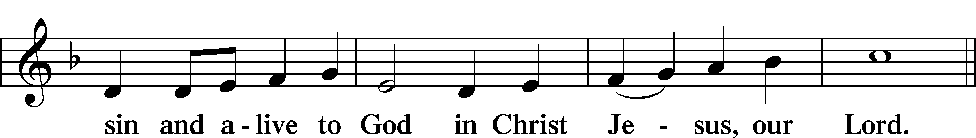

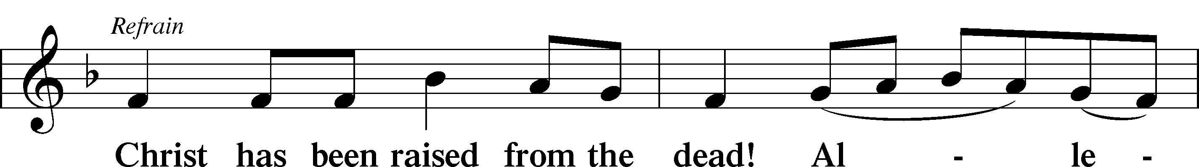

**+SERVICE OF THE SACRAMENT+**

**Preface**

**Sanctus**

**Prayer of Thanksgiving**

**The Words of Our Lord**

**Proclamation of Christ**

**Lord's Prayer**

**Pax Domini** *p180*

**Agnus Dei** *p180*

*Sit*

**Distribution**

***Beautiful Savior*** *LSB 537*

*Stand*

**Thank the Lord** *p181*

**Post-Communion Collect** *p183*

**Benediction** *p183*

***See, the Lord Ascends in Triumph*** *LSB 494*

***Acknowledgments***

*Unless otherwise indicated, all scripture quotations are from The Holy Bible, English Standard Version*, copyright © 2001 by Crossway Bibles, a division of Good News Publishers. Used by permission. All rights reserved.

Created by Lutheran Service Builder © 2006 Concordia Publishing House.