Messiah Lutheran Church—Missouri Synod

Rogate- Sixth Sunday of Easter
May 25, 2014
Divine Service II
James 1:22 “But be doers of the word, and not hearers only, deceiving yourselves.” The Word is God is not merely to be heard, but to be received and believed. Our faith is implanted and strengthened by the Word of God. And as Luther said, “Oh, it is a living, busy, active, mighty thing, this faith. And so it is impossible for it not to do good works incessantly.” James reminds us of this – and encourages us to examine our lives and come to repentance where we can see that we are not living out our faith in sincerity.
Messiah Lutheran Church
Rev. James A. Roemke, Pastor
2026 22nd Ave. Kenosha, WI 53140
Church Office: 262-551-8182 Parsonage: 262-551-0944
Website: www.messiahkenosha.org
Email: secretary@messiahkenosha.org
Pastor’s Cell: 262-455-0255 Christ Lutheran Academy: 262-697-6044

VISITORS WELCOME! A special welcome to any visitors and guests who are with us today. Please introduce yourself to the pastor after the service, and we pray that the hearing and receiving of the Word of God in our midst will be filled with joy and thanksgiving!

ATTENDANCE REGISTER: During the offering we ask that you sign the attendance register located at the center aisle of each pew. Please hand the filled in sheet to the usher as you exit at the end of the service. Let the usher know if you don’t have a pad in your pew.

HOLY COMMUNION is celebrated every Sunday and on Feast Days. Visiting communicant members of the Lutheran Church—Missouri Synod are invited to commune today. All other visitors are asked to speak with the pastor before coming to the altar. If there is time before the service, introduce yourself to the pastor or an elder. Other visitors are invited to use this time for prayer. If you desire information about attending communion, you are encouraged to visit with the pastor after the service today.

PRAYERS OF PREPARATION may be found in the opening cover of the hymnals in each pew. Take some time before the service begins in quiet preparation and prayer.

+SERVING TODAY+
Preacher/Celebrant: Pr. Roemke
Elder: Patrick Tauschek Ushers: Tyler Nehls & Austin Nehls
Greeter: Gail Kulbacki Organist: Evone Hagerman
Altar Guild: Diana Dissen & Marilyn Dissen
Cookies: Provided by Chuck and Anita Brothers. Thank you!
Flowers: Provided by the DelFrate family in honor of Gemma’s birthday and the Brothers family in honor of Anita’s and Becky’s birthdays.

This Is the Day the Lord Has Made LSB 903

Stand
The sign of the cross may be made by all in remembrance of their Baptism.
INVOCATION p167

+CONFESSION AND ABSOLUTION+
Silence for reflection on God's Word and for self-examination.

+SERVICE OF THE WORD+
Introit Ps. 66:1–2a, 17, 19–20; antiphon: Is. 48:20b
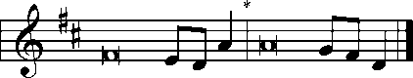
[With a voice of singing,] declare this with a shout of joy to the end of the earth. Alle- | luia.*
The Lord has redeemed his servant Jacob! Alle- | luia.
Shout for joy to God, | all the earth;*
sing the glory | of his name.
I cried to him | with my mouth,*
and high praise was | on my tongue.
But truly God has | listened;*
he has attended to the voice | of my prayer.
Blessèd | be God,*
because he has not rejected my prayer or removed his steadfast | love from me!

Glory be to the Father and | to the Son*
and to the Holy | Spirit;
as it was in the be- | ginning,*
is now, and will be forever. | Amen.

[With a voice of singing,] declare this with a shout of joy to the end of the earth. Alle- | luia.*
The Lord has redeemed his servant Jacob! Alle- | luia.
Kyrie p168
This is the Feast p171
Salutation and Collect of the Day
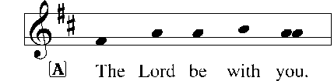
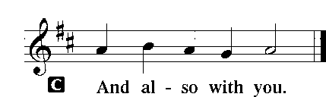

P | Let us pray.  O God, the giver of all that is good, by Your holy inspiration grant that we may think those things that are right and by Your merciful guiding accomplish them; through Jesus Christ, Your Son, our Lord, who lives and reigns with You and the Holy Spirit, one God, now and forever.
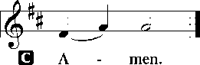
Sit
Old Testament Reading Numbers 21:4–9
⁴From Mount Hor they set out by the way to the Red Sea, to go around the land of Edom. And the people became impatient on the way. ⁵And the people spoke against God and against Moses, “Why have you brought us up out of Egypt to die in the wilderness? For there is no food and no water, and we loathe this worthless food.” ⁶Then the Lord sent fiery serpents among the people, and they bit the people, so that many people of Israel died. ⁷And the people came to Moses and said, “We have sinned, for we have spoken against the Lord and against you. Pray to the Lord, that he take away the serpents from us.” So Moses prayed for the people. ⁸And the Lord said to Moses, “Make a fiery serpent and set it on a pole, and everyone who is bitten, when he sees it, shall live.” ⁹So Moses made a bronze serpent and set it on a pole. And if a serpent bit anyone, he would look at the bronze serpent and live.
A | This is the Word of the Lord.
C | Thanks be to God.

Our Father, Who from Heaven Above LSB 766 v.1-4

Epistle 1 Timothy 2:1–6
¹First of all, then, I urge that supplications, prayers, intercessions, and thanksgivings be made for all people, ²for kings and all who are in high positions, that we may lead a peaceful and quiet life, godly and dignified in every way. ³This is good, and it is pleasing in the sight of God our Savior, ⁴who desires all people to be saved and to come to the knowledge of the truth. ⁵For there is one God, and there is one mediator between God and men, the man Christ Jesus, ⁶who gave himself as a ransom for all, which is the testimony given at the proper time.
A | This is the Word of the Lord.
C | Thanks be to God.
Stand
Alleluia and Verse
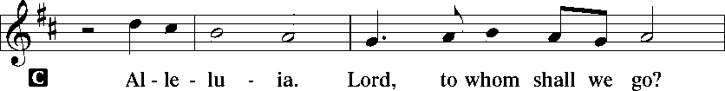
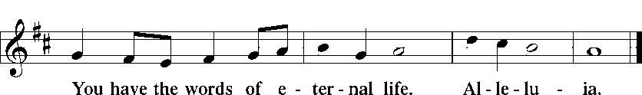

Holy Gospel John 16:23–30
P | The Holy Gospel according to St. John, the sixteenth chapter.
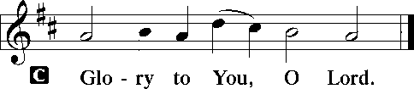

²³[Jesus said:] “In that day you will ask nothing of me. Truly, truly, I say to you, whatever you ask of the Father in my name, he will give it to you. ²⁴Until now you have asked nothing in my name. Ask, and you will receive, that your joy may be full.
²⁵“I have said these things to you in figures of speech. The hour is coming when I will no longer speak to you in figures of speech but will tell you plainly about the Father. ²⁶In that day you will ask in my name, and I do not say to you that I will ask the Father on your behalf; ²⁷for the Father himself loves you, because you have loved me and have believed that I came from God. ²⁸I came from the Father and have come into the world, and now I am leaving the world and going to the Father.”
²⁹His disciples said, “Ah, now you are speaking plainly and not using figurative speech! ³⁰Now we know that you know all things and do not need anyone to question you; this is why we believe that you came from God.”

P | This is the Gospel of the Lord.
Sit

Our Father, Who from Heaven Above LSB 766 v.5-9

Sermon
Stand
Nicene Creed
Prayer of the Church
Sit
Offering
Stand

Offertory-New Testament Canticle
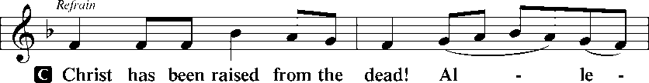
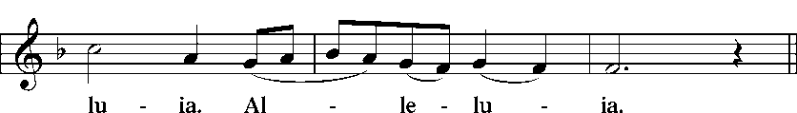
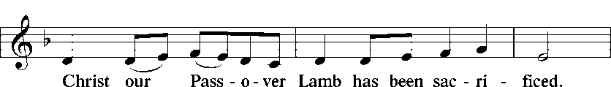
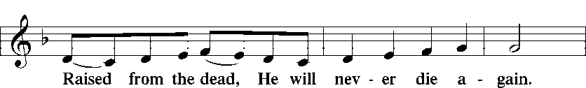
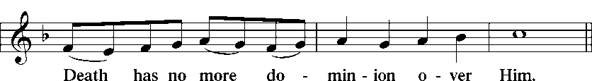
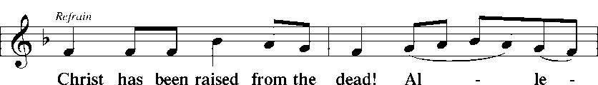
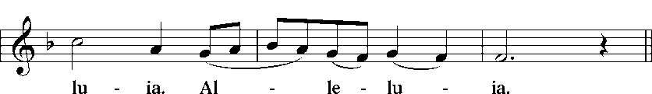
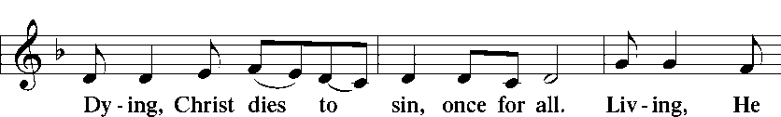
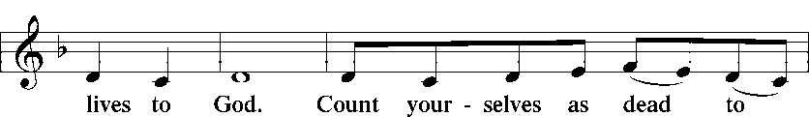
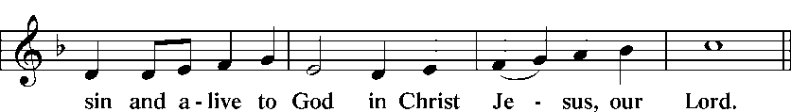
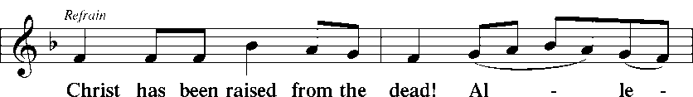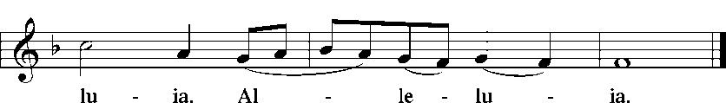

+SERVICE OF THE SACRAMENT+
Preface
Sanctus
Prayer of Thanksgiving
The Words of Our Lord
Proclamation of Christ
Lord's Prayer
Pax Domini p180
Agnus Dei p180
Sit
Distribution
All Hail the Power of Jesus' Name LSB 549
Lift High the Cross LSB 837
Jesus, Thy Blood and Righteousness LSB 563
Stand
Thank the Lord p181
Post-Communion Collect p183
Benediction p183

Now Thank We All Our God LSB 895

+PRAYER LIST+
- For all the children and Christ Lutheran Academy Staff: Debi Tauschek, Karen Moe, Ruth Mallmann, Stephanie Zuehls, Liesl Christensen, & Christa Hegland.
- Those who serve in our nation’s armed forces: Exor Padro, Ted & Katie Hart, and for veterans.
- Shut-ins: Elsie Rintamaki & Lillian Sciortino.
- For all those suffering from illnesses or other trials, including: Dennis Metallo, Joe Kayon, Richard Cleereman, Fred Dissen, Alison Daughtery (Metallo’s granddaughter), John Mills, Carla Krueger (cousin of Becky Noble), Diane Gundlach, Faith Peyron, Karin Zuehls (Jeff’s aunt), Diane Horschak (Debi Tauschek’s mother), and Rev. John Wille.

+ANNOUNCEMENTS FOR THE WEEK OF MAY 25, 2014+
KENOSHA KINGFISH GAME & TAILGATE PARTY: Sponsored by Thrivent. Friday, June 20 at 6:00 pm. Tickets are $5 per person. Reservations and payment must be made by June 1st. See poster in fellowship hall and talk to Lesa for more info and to purchase tickets.
CLA RUMMAGE SALE will be held June 12-14. If you have any extra items laying around your house that you would like to donate, please bring them to the church. In the past, adult clothing has not sold well, so we would prefer not to receive donations of that. But we will accept anything else, clean and in good condition. Contact Lesa Roemke with any questions.
ASCENSION DAY DIVINE SERVICE will be this Thursday, May 29th at 6:30 pm.
ISSUES, ETC. is a radio talk show produced by Lutheran Public Radio in Collinsville, IL and hosted by LCMS Pastor Todd Wilken. This week's topics include: The Movie "Godzilla," Was Adolf Hitler a Christian?, Speaking the Truth in Love to Mormons, The Hymn "The Strife Is O'er, the Battle Done," Noah, The Ascension of Jesus, Justin Martyr and more. You can listen on-demand at www.issuesetc.org.
INCOME

Budgeted Lord’s Work Needed Weekly: $3,717
Lord’s Work Received 5/18: $2,463
Difference Received vs. Needed: -$1,254
Difference Received vs. Needed Year to Date: -$4,960

ATTENDANCE Sunday 5/18: 111 Communed: 91

THIS WEEK’S EVENTS AT MESSIAH

5/27 Tuesday Choir Practice 7:00 pm
5/29 Thursday Ascension Divine Service 6:30 pm

UPCOMING EVENTS AT MESSIAH

6/8 Sunday Confirmation 9:00 am
6/12 – 6/14 CLA Rummage Sale 8:00 am
6/20 Friday Kenosha Kingfish Game 6:00 pm
6/22 Sunday Messiah vs. LOG Softball Game TBA

BIRTHDAYS BAPTISM BIRTHDAYS
5/25 Bryce Braya-Weyrauch 5/28 Allen Swift
Anita Brothers 5/29 Cole Pederson
Rebecca Brothers 5/31 Allen Weber
Sara Ricchio Nicole Wolgefahrt
5/28 Gemma DelFrate
5/29 Brody Pederson ANNIVERSARIES
5/31 Deborah Davidson None this week.

